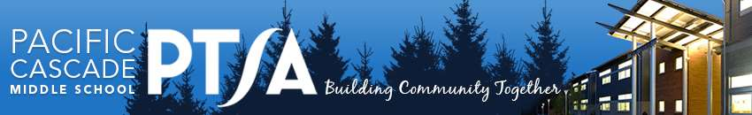
PCMS PTSA Curriculum Enrichment Grant Application
Pacific Cascade Middle School PTSA offers Annual Curriculum Enrichment Grants to provide additional resources for PCMS staff, supporting educational enrichment and opportunities. Grants are evaluated on NEED, ENRICHMENT, and IMPACT. All eligible applications are brought forward for PTSA General Membership vote, with grants to be implemented entirely within current academic calendar year.
Applicant(s):

Contact E-mail:

Total Funds Requested, including taxes, shipping, and other funding sources: student or school paid portion, district funds, ISF grants, previous grants:

Specific Grant Request Description and NEED:

ENRICHMENT: Describe educational qualities and merit of request?

IMPACT: How many students will be impacted by this Grant? Grade level(s)?

Additional Comments:

Complete all questions, attaching additional receipts, documentation, order details to fulfill application. Forward completed applications to the PCMS front office, or mail to PCMS PTSA Grants - 24635 SE Issaquah- Fall City Road, Issaquah, 98029. Questions, email Shilpa Sschuettenhelm @ sschuettenhelm@gmail.com.
Date of Submission:
Applicant Signature:
Principal Signature:
(Attach email confirmation of grant approval request, if necessary.)

